

Intimate Care Policy

Next review due by: 01.09.2026

Signed by (GBR):  Date: 01.09.2025

Name of Governing Body Representative: Kristofer McGhee


Contents
- Introduction
- Procedures
- Children wearing nappies
- Equipment provision
- Health and safety
- First aid and intimate care
- Appendices

- Introduction

Intimate care is any care which involves washing, touching or carrying out an invasive procedure (such as cleaning up a pupil after they have soiled themselves) to intimate personal areas. In most cases such care will involve cleaning for hygiene purposes as part of a staff member’s duty of care. In the case of a specific procedure only a person suitably trained and assessed as competent should undertake the procedure.

The issue of intimate care is a sensitive one and will require staff to be respectful of the child’s needs. The child's dignity should always be preserved with a high level of privacy, choice and control. There shall be a high awareness of child protection issues. Staff behaviour must be open to scrutiny and staff must work in partnership with parents/ carers to provide continuity of care to children/young people wherever possible.

Princess May Primary School is committed to ensuring that all staff responsible for the intimate care of children will undertake their duties in a professional manner at all times. Princess May Primary School recognises that there is a need to treat all children with respect when intimate care is given. No child should be attended to in a way that causes distress or pain.

- Procedures

  - The management of all children with intimate care needs will be carefully planned. The child who requires intimate care is treated with respect at all times; the child's welfare and dignity is of paramount importance.

2.2 Staff who provide intimate care are trained to do so (including Child Protection and Health and Safety training in lifting and moving) and are fully aware of best practice. Apparatus will be provided to assist with children who need special arrangements following assessment from physiotherapist/ occupational therapist as required.

2.3 Staff will be supported to adapt their practice in relation to the needs of individual children taking into account developmental changes such as the onset of puberty and menstruation. Wherever possible staff who are involved in the intimate care of children/young people will not usually be involved with the delivery of sex education to the children/young people in their care as an additional safeguard to both staff and children/young people involved.

2.4 The child will be supported to achieve the highest level of autonomy that is possible given their age and abilities. Staff will encourage each child to do as much for him/herself as he/she can. This may mean, for example, giving the child responsibility for washing themselves. Individual intimate care plans will be drawn up for particular children as appropriate to suit the circumstances of the child. These care plans can be found in Appendix 2. Parental permission will also be sought prior to intimate care being carried out. The permission form to be filled out can be found in Appendix 1.

2.5 Each child's right to privacy will be respected. Careful consideration will be given to each child's situation to determine how many carers might need to be present when a child is toileted. Where possible one child will be catered for by one adult unless there is a sound reason for having more adults present. If this is the case, the reasons should be clearly documented and will be reviewed if staff are unable to carry this out.

2.6 The child will be cared for by a familiar adult in the class team. The responsibility for intimate care will not rest on a single person but 2-3 people, known to the child. This will ensure, as far as possible, that over-familiar relationships are discouraged from developing, whilst at the same time guarding against the care being carried out by a succession of completely different carers.

2.7 Intimate care arrangements will be discussed with parents/carers on a regular basis. The needs and wishes of children and parents will be taken into account wherever possible within the constraints of staffing and equal opportunities legislation.

2.9 A child’s intimate care needs should be met by the first available member of staff known to the child, providing it is safe to do so. It is not appropriate to wait for the child’s 1:1 adult to change them, providing there is a known and familiar adult on hand to do so.

Toileting Incidents:
2.10 In the event of a toileting accident (e.g. soiling or urination), the office will be informed immediately. The office will locate suitable clean clothing (where required) and provide this to the child, who will be taken to the nearest toilet. A first-aid trained adult will then remain outside the toilet (ensuring no other pupils enter) until the child is changed and in suitable clothing and will then return the child to the classroom.
2.11 If the pupil requires support with changing, staff must follow the protective measures outlined in Section 5 (Health and Safety) of this policy — wearing gloves and aprons, disposing of waste in the designated hygiene bin, and ensuring another adult is aware that intimate care is being provided.
2.12 Office staff must record the incident on the pupil’s Arbor profile under the ‘medical’ section, including a brief description of the incident. Parents will be informed by telephone immediately following the incident, and SLT will also be informed on the same day via email.

- Children wearing nappies

  - Schools may have concerns regarding Child Protection issues when they are asked by parents to admit a child who is still wearing nappies. Child protection need not present an issue. It is good practice to provide information for parents of the policy and practice in the school. Such information should include a simple agreement form for parents to sign, outlining who will be responsible for changing the child and when and where this will be carried out. This agreement allows the school and the parent to be aware of all the issues surrounding this task right from the outset.

  - We will record who changes a child, how often this task is carried out and the time they left/returned to the classroom following this task. Examples of such good practice provide reassurance for parents that systems are in place and that schools have implemented procedures for staff to follow.

  - Under certain circumstances, it may be necessary to ask parents to ensure children are toilet trained prior to entry into the nursery. For example, if a child is unable to be changed safely or this puts other children or staff members at risk.

- Equipment provision

  - Schools often ask for clarification regarding who is responsible for providing equipment when children require changing. Parents have a role to play when their child is still wearing nappies. The parent should provide nappies, disposal bags, wipes, changing mat etc. and parents should be made aware of this responsibility. Schools are responsible for providing gloves, plastic aprons, a bin and liners to dispose of any waste.

- Health and safety

5.1 Some schools are concerned about health and safety issues when staff are changing children or dealing with a child who has had an accident and is bleeding.

5.2 Staff should always wear an apron and gloves when dealing with a child who is bleeding or soiled or when changing a soiled nappy. Any soiled waste should be placed in a polythene waste disposal bag, which can be sealed. This bag should then be placed in a bin (complete with a liner) which is specifically designated for the disposal of such waste. The bin should be emptied on a weekly basis and it can be collected as part of the usual refuse collection service as this waste is not classed as clinical waste. Staff should be aware of the school’s Health and Safety policy.

- First Aid and intimate care

6.1 Staff who administer intimate first aid should ensure wherever possible that another adult is aware of the procedure taking place. The pupil’s dignity must always be considered and where contact of a more intimate nature is required, another member of staff should be in the vicinity and should be made aware of the task being undertaken. The procedure should be recorded.

6.2 We will record who changes a child, how often this task is carried out and the time they left/returned to the Regular requirements of an intimate nature should be planned for. Agreements between the school/organisation, those with parental responsibility and the child concerned should be documented and easily understood. The necessity for such requirements should be reviewed regularly. The child’s views must also be actively sought and, in particular, any discomfort with the arrangements addressed.

- Appendices

Appendix 1- permission form for intimate care



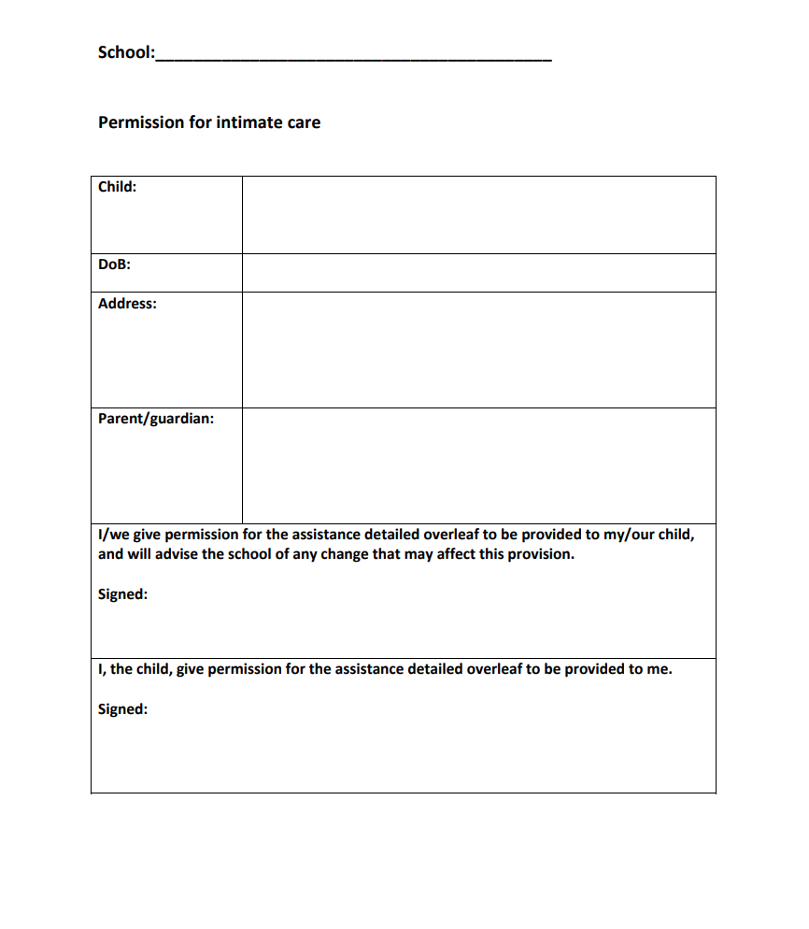

Appendix 2- intimate care plan

